**Dear visitor collector,**

**Collecting-stamps: this website is an encyclopaedia of Belgian stamps and is gradually being updated.**

**Plenty of viewing pleasure,  
MZ**

[STAMPS-BE ALBUM](https://stamps-be-album.jouwweb.be/)►EN

[postzegelalbum-be](https://www.postzegelalbum-be.com/)► NL

[TIMBRES-BE-ALBUM](https://timbres-be-album.jouwweb.be/) ► FR

**Why collect stamps? © bpost**

Quote from flr 6/71: "SAVE POSTAGE STAMPS, KNOWLEDGE IS COLLECTED":  
"The Stamp" tells about all domains of science: Geography, History, Science, Mathematica, Art, Languages, the human, his world, his realizations and his visions of the future. The image of the stamps is a true representation of reality and appeals through its beauty, rich colours and special shapes, which greatly enhance the visual charm of the stamp. "

**What can you use this website for and how do I keep my stamp collection organized?**

This website [STAMPS-BE ALBUM](https://stamps-be-album.jouwweb.be/) is an encyclopaedia of Belgian stamps with special publication information. These are available from Y1955 (1st flyer edition)  
For the current stamps such as Heraldic Lion, Royal effigies, birds, etc., there is usually no information available.  
Information with descriptions of the stamps cannot be found on this website, but you can request it FREE (without obligation) via the contact form (Dutch version translated)  
All Belgian stamps up to Y2020 with their characteristics have been inventoried (PDF files).

**\*marking of last published stamps =>**

The numbering of the stamps / blocks / / booklets / sheets has not yet been officially confirmed. They are marked with**\***  
The layouts in the albums were arranged in the order published by Bpost.

**For your information:**

- The dates in these albums are the dates of the first availability of the stamps, namely during pre-sales or not.

- From Y1955, both the presale (if any) and the issue dates were listed  
- In the OBP (Official Belgian stamps) catalogue, the dates up to No. **3929/3938** are presale dates if there are any - otherwise according to the issue date. From No. **3939** the dates of issues are mentioned and no more of the presales. (the reason is unknown to me)

**Availability:**

- Some of the stamps are marked with ► image not available

- Some blocks / / booklets / sheets are marked ** ► not available

**What can you expect from these albums?**  
These albums of the Belgian stamps are made to have a more clear overview of the publications.  
- You can classify the stamps as needed by using Hawid clamping strips.  
- You can then easily make an album with the stamps on one page followed by one or two pages with the info. (only from Y1955)  
- To my knowledge there are so far only very boring albums available on the market to insert only the stamps, without the accompanying information sheets, and I missed that .... I never just put stamps in an album without that I have the story of the image on it available (if available in flyers and Philanews published by Bpost since Y1955).  
- Below you can find an example of how I approached the classification. (this from Y1955)

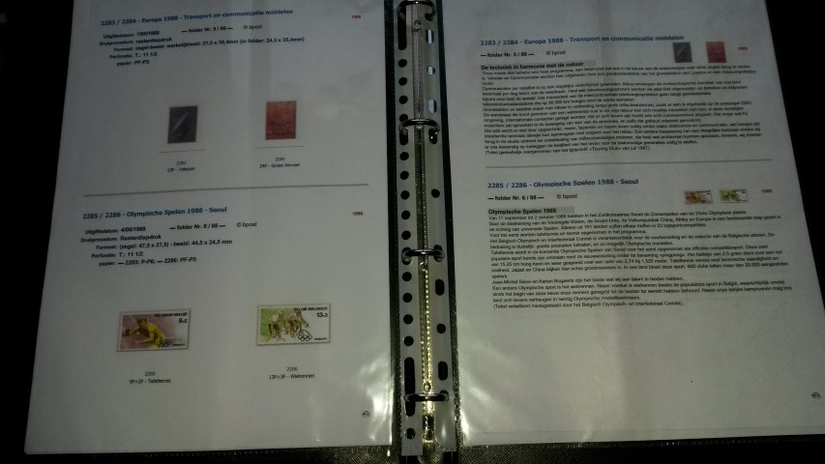

**How do you navigate through the website of this free stamp album?**

- To view the album, you can consult the content directly by scrolling or by opening the attachments, downloading the "scribd" or the PDF.  
- To consult the characteristics / booklets (**B…**) / small sheets (**F….**) and other sheets (**V..-….**) of all stamp issues, you can access the appropriate shortcuts for each page of the album.

- From No. **961** (Y1955) there are also the info (theme description of the stamps) available of the special stamps issued by the Bpost.  
- As mentioned earlier, these are not published here, but can be requested free of charge via the contact form.  
- You can also find the info of the special stamps in the flyer / Philanews published by the Post from - - date of publication.  
>> Unfortunately the flyer (Y1955-Y1998) / Philanews (small size Y1999- "4-2009") are no longer available on the Bpost sites. >> Philanews large format are however available from volume Y2010 (2009-5 large format not available.

**Extra information:**

* **In “Intro”:** 
  + **Intro 1: Terms**
  + **Intro 2: Contents**
  + **intro 3: Contact - suggestions - appreciations**
* **In “Info”:**
  + **Info 1: Belgium Stamps - Paper types**
  + **Info 2: Franking values ​​from 01/10/2007**
  + **Info 3: Stamp list complete + inventory (Y1849►today) (in xlsx form)**

▼ to you to create the below pdf files or not ▼

* + - **Info 3a: List Stamps + inv. J1849 - J1957 (1-1045)**
    - **Info 3b: List Stamps + inv. J1958 - J1998 (1046-2792) (+ flyers)**
    - **Info 3c: List Stamps + Inv. J1999 -b J2009 (2792- 3969) (+ Philanews A5)**
    - **Info 3d: List Stamps + inv. J2010 - J2014 (3970-4896) (+ Philanews ± A4)**
    - **Info 3e: List Stamps + inv. J2015 - J2019 (4897-4896) (+ Philanews ± A4)**
    - **Info 3f: List Stamps + inv. J2020 - J2029 (4897-4 ....) * (+ Philanews ± A4)**
  + **Info 4: Flyer lists**
  + **Info 5: Philanews lists A5 format**
  + **Info 6: Philanews lists ± A4 format**
    - * **Info 6a: lists J2009 (09) - J2019 (3970-4896) ± A4 format**
      * **Info 6b: lists J2020 - J2029 (4897 -....) ± A4 format**
  + **Info 7: FDC list**

► nn° =no number - tnr°.= tracking n°

* + From No. **785**, the first FDC (First Day Cover: Published by the Bpost) has been published according to the official catalogues (published by V.Z.W.O.).  
    - From No. **961** (year 1955 - flyer nn° / 1955 tnr°. 1), information files are available and the printing procedures are as described in the flyers.  
    - From No. **1532** (year 1970 - flyer 7/1970): the stamp image formats are mentioned as in the flyers.  
    - From No. **1683** (year 1973 - flyer 14/1973): the paper types are listed as in the flyers.  
    - From No. **1723** (year 1974 – flyer 10 / 1974): the perforations are mentioned as in the flyers. All characteristics are therefore from No. **1723** to No. 2792 as mentioned in the flyers.   
    - From No. **2793** (Volume 1999 - Philanews 1/1999): All characteristics are from No. **2793** to **3969** as mentioned in the "Philanews (small size ± A5)" information brochures.  
    - From No. **3970** (year 2009 - Philanews 5/2009): all characteristics as mentioned in the "Philanews (large size ± A4)" information brochures.

**Are all old stamps still valid? © bpost**

The ministerial decree of July 11, 1962 states: "All stamps still in circulation as of July 11, 1962, as well as all stamps that will appear hereafter, have permanent franking validity." This means that all postage stamps issued after 1962 are still valid today, even if they were in Belgian Francs or unstamped.

PS: - This album has been prepared in accordance with the rules of Bpost (see Philanews 2013/03 pg 18: FAQ © bpost).  
Officially online since 2/25/2019 (Dutch version: <https://postzegelalbum-be.jouwweb.be/>) with written permission from Bpost.  
- If you have spotted a mistake or have any suggestions, they are more than welcome, thank you.  
  
Plenty of viewing pleasure, MZ